**Assumptions/Clarifications on requirements:**

1. Type of user will be retrieved from database upon user login and hence the value of this field is available.
   * E – Employee
   * A – Affiliate
   * L – Loyal customer for over 2 years

Note: Can be calculated and set in DB field by cron job on daily basis or always calculate based on signup date field from DB or have a check while sign in to update the field if matches the loyal customer criteria.

* + 1. For this sample, I prefer value ‘L’ is coming as input for ease.

1. $5 discount on every $100 on the bill, assumed to be total bill amount irrespective of the applied discount and this is for every type of user purchase in the benefit of customer unless told otherwise.
2. Filter out the non-grocery items for subset of total bill to calculate the percentage discounts for different user types.
3. For simplicity, a flag for grocery is introduced, otherwise we can standardise item code series range to differentiate groceries.

**Current Scope:**

1. Assume Bill contains the list of items which needs for calculation.
2. Each item object contains itemCode, price, isGrocery.

**Future Scope:**

1. Item object can be enhanced with field discountPrice to hold individual item discount for itemized billing on discounts.
2. Can be enhance by writing separate methods for processing/setting individual item discountPrice, calculating total and percentae discount and expose as public to use them as utility service.

Input: List of Item objects and user type from Bill

Output: Net payable amount.

**LLD**

1. **Class diagram**

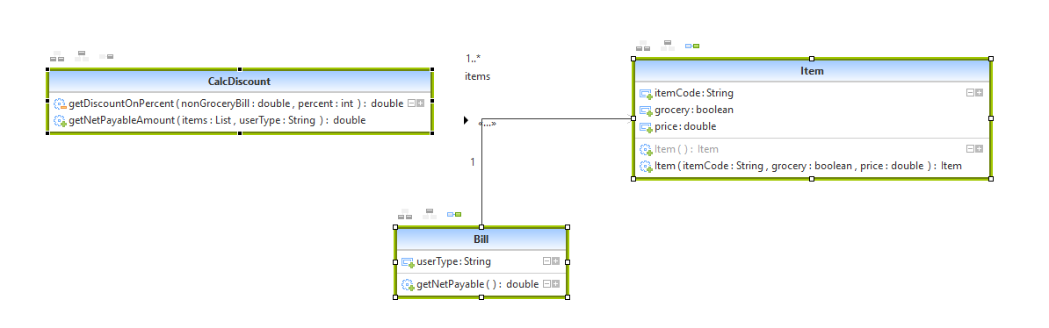

1. **Flow chart for getNetPayableAmt**

Add 30% of non-grocery to discountPrice

userType

Set required vars to 0

Calculate GrossAmount and gross amount for non-groceries from items

Extract $5 per $100 from bill amount and hold in var discountPrice

E

NA

Add 10% of non-grocery to discountPrice

Calculated A

Add 5% of non-grocery to discountPrice

L